Atlantic Technological University- Donegal
Postgraduate Diploma in DevOps
Module: Project Management
Group 3

Assignment:
Project Description:

Online Booking System for range of horror themed adventure parks

Wednesday’s Wicked Adventures
The end customer would like an online booking system for range of horror themed adventure parks.
Their most popular product is Risky Rollercoaster.
The system must take details of customer map them to the themed adventure park of their choice along with a single box for extra set of health and warning checkboxes.
The system should be clean and simple.
Your team has been tasked with creating the pipeline for the SDLC.
You have also been asked to provide a simple prototype page(s) to test the pipeline.
The system needs to take into account the usual security requirements.
The administrator of the end system (Wednesday or Pugsley) should be able to access detailed information and edit as appropriate.
Once the client enters details it should not be able to be changed by the holiday maker.
Your customers are representative of real customers.
They require a lot but for a small price.
They are prone to changing their mind. will initiate project

Research into MongoDB database for the project
This spike is to look into MongoDB database and how it can be used for this project
What is MongoDB
How to install MongoDB database server
Where to install the database server- local machine or in cloud
How to create a MongoDB cluster
How to connect to MongoDB database
What MongoDB Query API is
How to use MongoDB Query API
How to create, change and show MongoDB databases
How to create collection in MongoDB using mongosh
How to insert data/documents in MongoDB database
How to find data

What is MongoDB
MongoDB is a non-SQL,
document database.
It stores data in a type of JSON format called BSON
A record in MongoDB is a document, which is a data structure composed of key value pairs similar to the structure of JSON objects

How to install MongoDB database server
Two installation options
MongoDB Atlas- MongoDB as a Service (Hosted Database)
MongoDB On=premises- installed locally

How to sign up for MongoDB Atlas for Hosted Database

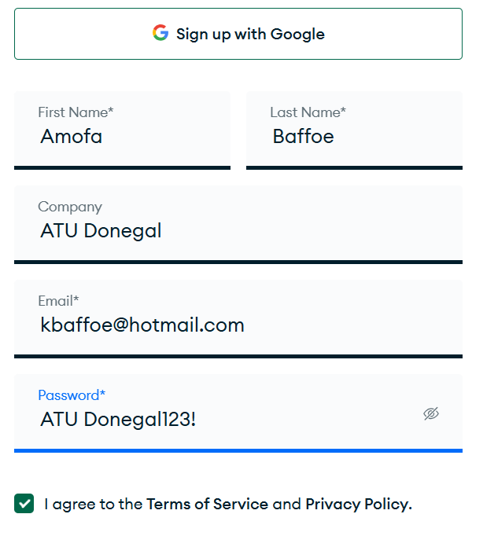
After email verification:

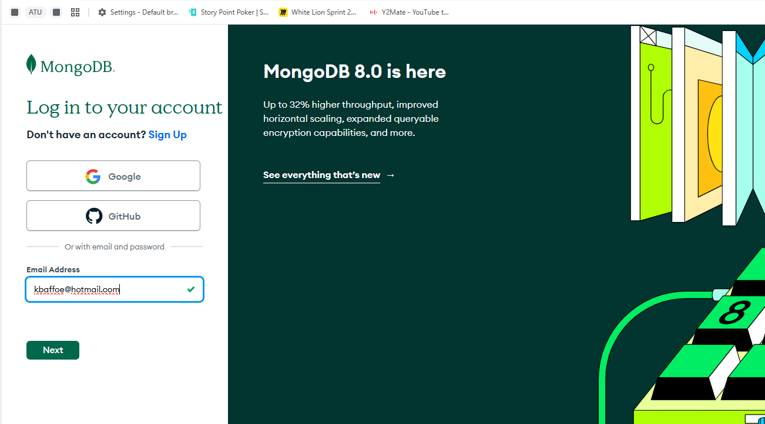

Next:
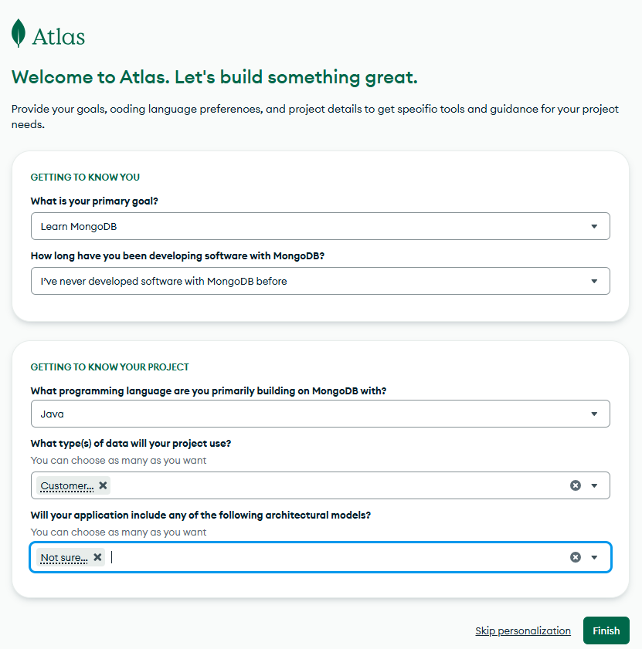
Next..select “Free”
Cluster Name: ATUCluster

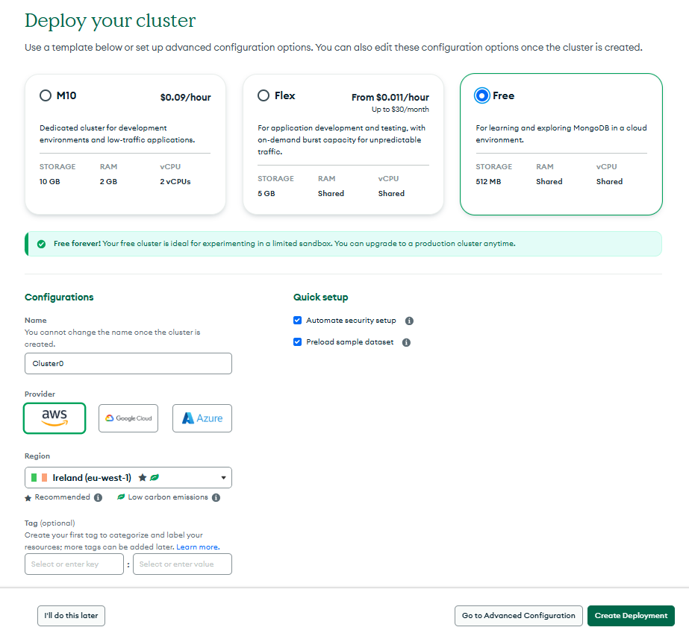

Username: kbaffoe
Password: pwlSEPtOwi6CJa9P

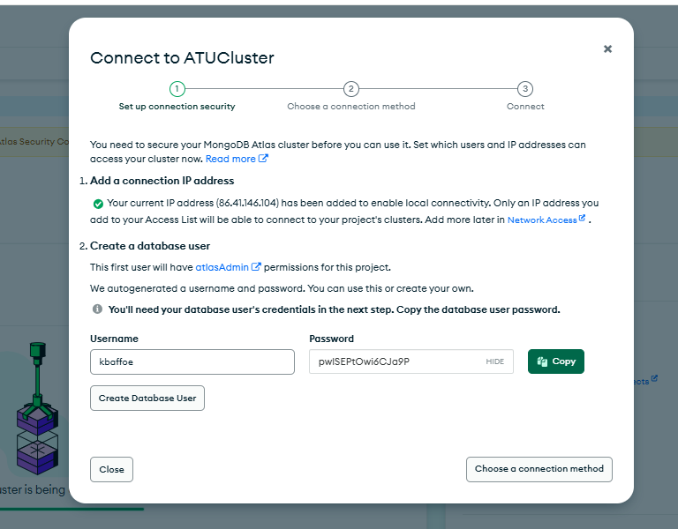

Creating a Cluster
After you have created your account, set up a free "Shared Cluster" then choose your preferred cloud provider and region.
By default, MongoDB Atlas is completely locked down and has no external access.
You will need to set up a user and add your IP address to the list of allowed IP addresses.
Under "Database Access", create a new user and keep track of the username and password.
Next, under "Network Access", add your current IP address to allow access from your computer.

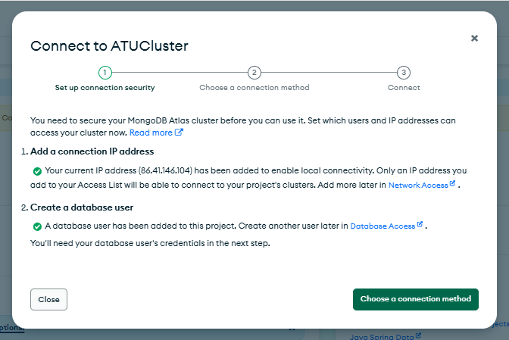

Where to add more users/IP addresses to access cluster:
https://cloud.mongodb.com/v2/67cb62fb10592e571eb153e7#/security/network/accessList
Wher5e to add users to access database:
https://cloud.mongodb.com/v2/67cb62fb10592e571eb153e7#/security/database/users
In the MongoDB Atlas dashboard, under "Databases", click the "Connect" button for your Cluster.

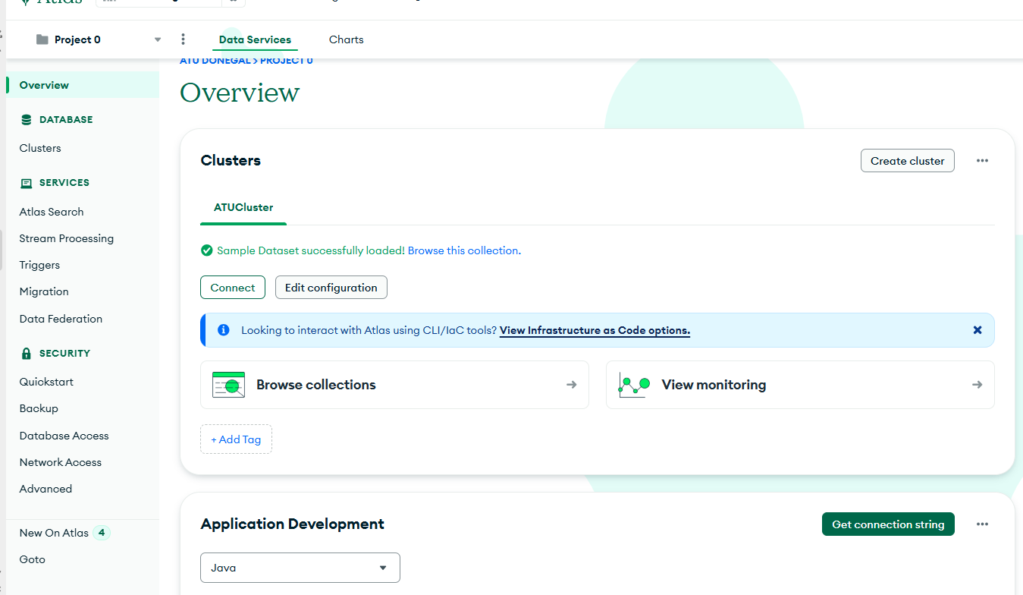

Click Shell
Copy connection string
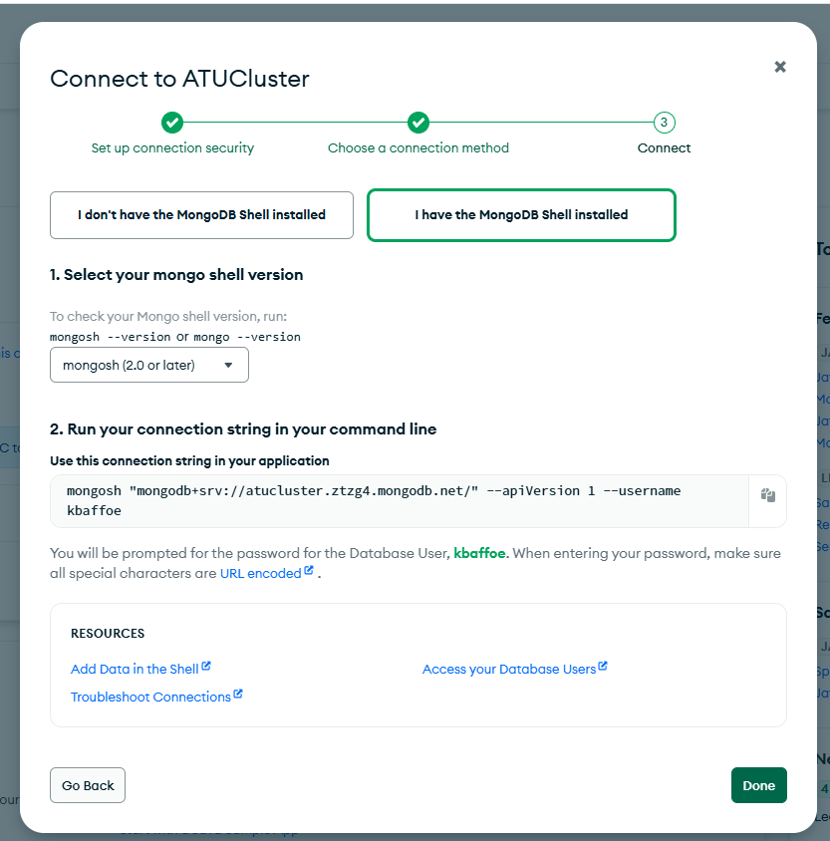

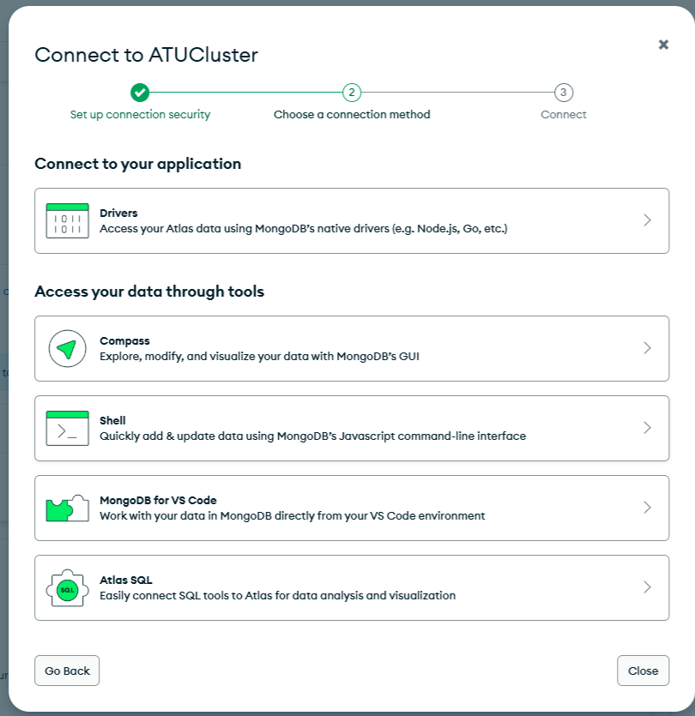
Enter connection details (from above)
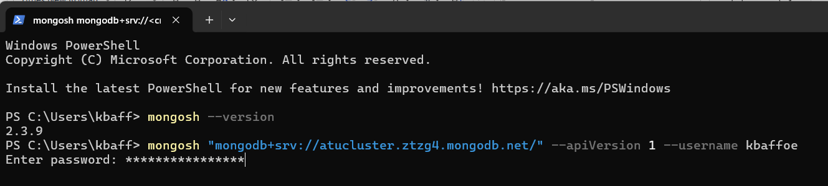
Connection successfully established:
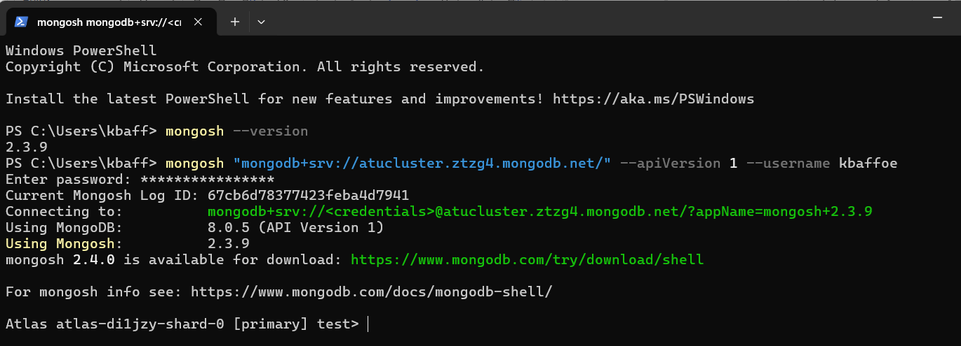
How data is structured in MongoDB
Records in a MongoDB database are called documents, and the field values may include numbers, strings, booleans, arrays, or even nested documents.
Example document:
{
title: "Post Title 1",
body: "Body of post.",
category: "News",
likes: 1,
tags: ["news", "events"],
date: Date()}
Sample search:
Find all documents that have a category of "news".
db.posts.find( {category: "News"} )
Expected result:
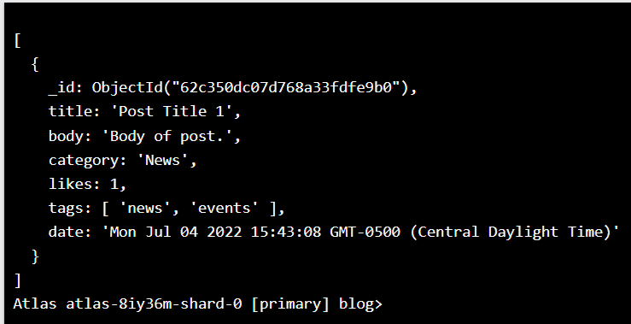
Sample blog post object stored in MongoDBV
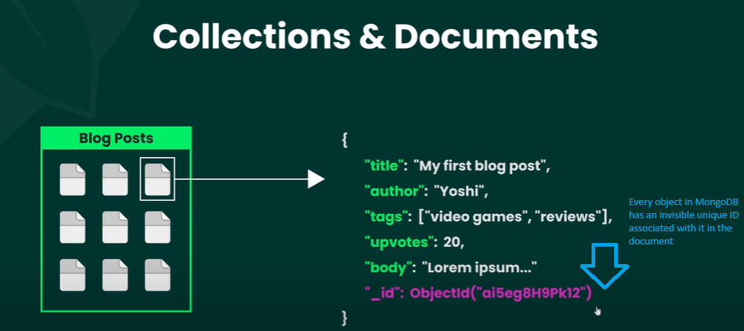
Can search data using the unique ID assigned by MongoDB
Documents can have properties whose values themselves are documents or array of documents- nested documents

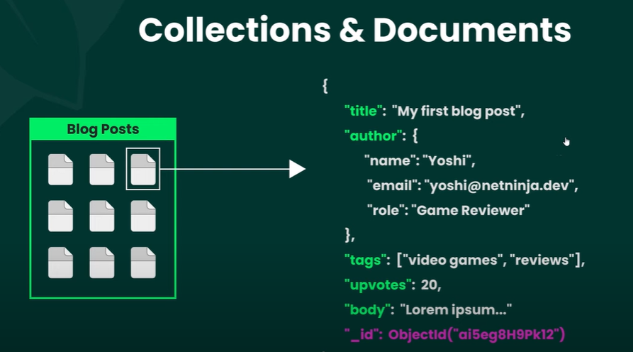
Author property (above) is a nested document- with name, email and role properties
MongoDB CRUD Operations
CRUD operations create, read, update, and delete documents.
You can connect with driver methods and perform CRUD operations for deployments hosted in the following environments:
Create Operations
Create or insert operations add new documents to a collection. If the collection does not currently exist, insert operations will create the collection.
MongoDB provides the following methods to insert documents into a collection:
db.collection.insertOne()
db.collection.insertMany()
In MongoDB, insert operations target a single collection. All write operations in MongoDB are atomic on the level of a single document.
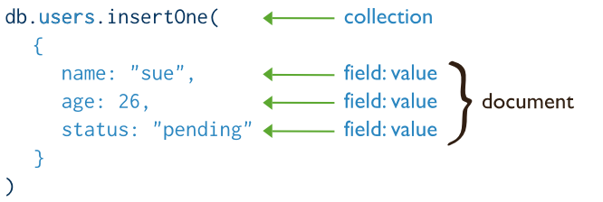
Insert examples
Insert Documents in the MongoDB Atlas UI
- In the MongoDB Atlas UI, go to the Clusters page for your project.
- If it's not already displayed, select the organization that contains your desired project from the Organizations menu in the navigation bar.
- If it's not already displayed, select your project from the Projects menu in the navigation bar.
- If it's not already displayed, click Clusters in the sidebar.
The Clusters page displays.Navigate to the collection
- For the cluster to which you want to add documents, click Browse Collections.
- In the left navigation pane, select the database.
- In the left navigation pane, select the collection.
- Add the documents
- Click Insert Document.
- Click the {} icon, which opens the JSON view.
- Paste the document array into the text entry field. For example, the following entry creates four documents, each of which contain three fields:
[
{ "prodId": 100, "price": 20, "quantity": 125 },
{ "prodId": 101, "price": 10, "quantity": 234 },
{ "prodId": 102, "price": 15, "quantity": 432 },
{ "prodId": 103, "price": 17, "quantity": 320 }
]
Insert a Single Document
Collection.insertOne() inserts a single document into a collection.
The following example inserts a new document into the inventory collection.
If the document does not specify an _id field, the Node.js driver adds the _id field with an ObjectId value to the new document.
await db.collection('inventory').insertOne({
item: 'canvas',
qty: 100,
tags: ['cotton'],
size: { h: 28, w: 35.5, uom: 'cm' }
});
Node.jsinsertOne() returns a promise that provides a result. The result.insertedId promise contains the _id of the newly inserted document.
To retrieve the document that you just inserted, query the collection:
const cursor = db.collection('inventory').find({ item: 'canvas' });
Insert Multiple Documents
Collection.insertMany() can insert multiple documents into a collection. Pass an array of documents to the method.
The following example inserts three new documents into the inventory collection. If the documents do not specify an _id field, the Node.js driver adds the _id field with an ObjectId value to each document.
await db.collection('inventory').insertMany([
{
item: 'journal',
qty: 25,
tags: ['blank', 'red'],
size: { h: 14, w: 21, uom: 'cm' }
},
{
item: 'mat',
qty: 85,
tags: ['gray'],
size: { h: 27.9, w: 35.5, uom: 'cm' }
},
{
item: 'mousepad',
qty: 25,
tags: ['gel', 'blue'],
size: { h: 19, w: 22.85, uom: 'cm' }
}
]);
insertMany() returns a promise that provides a result. The result.insertedIds field contains an array with the _id of each newly inserted document.
To retrieve the inserted documents, query the collection:
const cursor = db.collection('inventory').find({});

Insert Behavior
Collection Creation
If the collection does not currently exist, insert operations will create the collection.
_id Field
In MongoDB, each document stored in a standard collection requires a unique _id field that acts as a primary key. If an inserted document omits the _id field, the MongoDB driver automatically generates an ObjectId for the _id field.
This also applies to documents inserted through update operations with upsert: true.
Atomicity
All write operations in MongoDB are atomic on the level of a single document. For more information on MongoDB and atomicity, see Atomicity and Transactions
Read Operations
Read operations retrieve documents from a collection; i.e. query a collection for documents. MongoDB provides the following methods to read documents from a collection:
db.collection.find()
You can specify query filters or criteria that identify the documents to return.
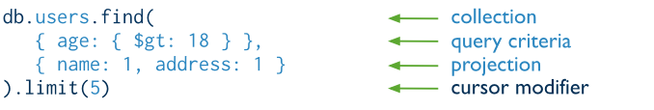
To query documents, specify a query predicate indicating the documents you want to return. If you specify an empty query predicate ({ }), the query returns all documents in the collection.
You can query documents in MongoDB by using the following methods:
- Your programming language's driver.
- The MongoDB Atlas UI.
- MongoDB Compass.
Use the Select your language drop-down menu in the upper-right to set the language of the following examples or select MongoDB Compass.
This page provides examples of query operations using the Collection.find() method in the MongoDB Node.js Driver.
The examples on this page use the inventory collection. Connect to a test database in your MongoDB instance then create the inventory collection:
This page provides examples of query operations using the Collection.find() method in the MongoDB Node.js Driver.
The examples on this page use the inventory collection. Connect to a test database in your MongoDB instance then create the inventory collection:
Node.js examples
await db.collection('inventory').insertMany([
{
item: 'journal',
qty: 25,
size: { h: 14, w: 21, uom: 'cm' },
status: 'A'
},
{
item: 'notebook',
qty: 50,
size: { h: 8.5, w: 11, uom: 'in' },
status: 'A'
},
{
item: 'paper',
qty: 100,
size: { h: 8.5, w: 11, uom: 'in' },
status: 'D'
},
{
item: 'planner',
qty: 75,
size: { h: 22.85, w: 30, uom: 'cm' },
status: 'D'
},
{
item: 'postcard',
qty: 45,
size: { h: 10, w: 15.25, uom: 'cm' },
status: 'A'
}
]);

Select All Documents in a Collection

To select all documents in the collection, pass an empty document as the query filter parameter to the find method.
The query filter parameter determines the select criteria:
const cursor = db.collection('inventory').find({});
This operation uses a query predicate of {}, which corresponds to the following SQL statement:
SELECT * FROM inventory
Specify Equality Condition
To specify equality conditions, use <field>:<value> expressions in the query filter document:
{ <field1>: <value1>, ... }
The following example selects from the inventory collection all documents where the status equals "D":
const cursor = db.collection('inventory').find({ status: 'D' });
This operation uses a query predicate of { status: "D" }, which corresponds to the following SQL statement:
SELECT * FROM inventory WHERE status = "D
Specify Conditions Using Query Operators
A query filter document can use the query operators to specify conditions in the following form:
{ <field1>: { <operator1>: <value1> }, ... }
The following example retrieves all documents from the inventory collection where status equals either "A" or "D":
const cursor = db.collection('inventory').find({status: { $in: ['A', 'D'] }});
The operation uses a query predicate of { status: { $in: [ "A", "D" ] } }, which corresponds to the following SQL statement:
SELECT * FROM inventory WHERE status in ("A", "D")
Specify AND Conditions
A compound query can specify conditions for more than one field in the collection's documents. Implicitly, a logical AND conjunction connects the clauses of a compound query so that the query selects the documents in the collection that match all the conditions.
The following example retrieves all documents in the inventory collection where the status equals "A" and qty is less than ($lt) 30:
const cursor = db.collection('inventory').find({
status: 'A',
qty: { $lt: 30 }
});
The operation uses a query predicate of { status: "A", qty: { $lt: 30 } }, which corresponds to the following SQL statement:
SELECT * FROM inventory WHERE status = "A" AND qty < 30
Specify OR Conditions
Using the $or operator, you can specify a compound query that joins each clause with a logical OR conjunction so that the query selects the documents in the collection that match at least one condition.
The following example retrieves all documents in the collection where the status equals "A" or qty is less than ($lt) 30:
const cursor = db.collection('inventory').find({
$or: [{ status: 'A' }, { qty: { $lt: 30 } }]
});
The operation uses a query predicate of { $or: [ { status: 'A' }, { qty: { $lt: 30 } } ] }, which corresponds to the following SQL statement:
SELECT * FROM inventory WHERE status = "A" OR qty < 30
Specify AND as well as OR Conditions
In the following example, the compound query document selects all documents in the collection where the status equals "A" and either qty is less than ($lt) 30 or item starts with the character p:
const cursor = db.collection('inventory').find({
status: 'A',
$or: [{ qty: { $lt: 30 } }, { item: { $regex: '^p' } }]
});
The operation uses a query predicate of:
status: 'A',
$or: [
{ qty: { $lt: 30 } }, { item: { $regex: '^p' } }
]
}
which corresponds to the following SQL statement:
SELECT * FROM inventory WHERE status = "A" AND ( qty < 30 OR item LIKE "p%")
Update Operations
Update operations modify existing documents in a collection. MongoDB provides the following methods to update documents of a collection:
In MongoDB, update operations target a single collection. All write operations in MongoDB are atomic on the level of a single document.
You can specify criteria, or filters, that identify the documents to update. These filters use the same syntax as read operations.

You can update documents in MongoDB using the following methods:
- Your programming language's driver.
- The MongoDB Atlas UI. To learn more, see Update a Document with MongoDB Atlas.
- MongoDB Compass.
This page uses the following MongoDB Node.js Driver methods:
Collection.updateOne()
Collection.updateMany()
Collection.replaceOne()
The examples on this page use the inventory collection.
Connect to a test database in your MongoDB instance then create the inventory collection:
await db.collection('inventory').insertMany([
{
item: 'canvas',
qty: 100,
size: { h: 28, w: 35.5, uom: 'cm' },
status: 'A'
},
{
item: 'journal',
qty: 25,
size: { h: 14, w: 21, uom: 'cm' },
status: 'A'
},
{
item: 'mat',
qty: 85,
size: { h: 27.9, w: 35.5, uom: 'cm' },
status: 'A'
},
{
item: 'mousepad',
qty: 25,
size: { h: 19, w: 22.85, uom: 'cm' },
status: 'P'
},
{
item: 'notebook',
qty: 50,
size: { h: 8.5, w: 11, uom: 'in' },
status: 'P'
},
{
item: 'paper',
qty: 100,
size: { h: 8.5, w: 11, uom: 'in' },
status: 'D'
},
{
item: 'planner',
qty: 75,
size: { h: 22.85, w: 30, uom: 'cm' },
status: 'D'
},
{
item: 'postcard',
qty: 45,
size: { h: 10, w: 15.25, uom: 'cm' },
status: 'A'
},
{
item: 'sketchbook',
qty: 80,
size: { h: 14, w: 21, uom: 'cm' },
status: 'A'
},
{
item: 'sketch pad',
qty: 95,
size: { h: 22.85, w: 30.5, uom: 'cm' },
status: 'A'
}
]);

Update Documents in a Collection
To update a document, MongoDB provides update operators such as $set to modify field values.
To use the update operators, pass to the update methods an update document of the form:
{
<update operator>: { <field1>: <value1>, ... },
<update operator>: { <field2>: <value2>, ... },
}
Some update operators, such as $set, will create the field if the field does not exist. See the individual update operator reference for details.
Update a Single Document
The following example uses the Collection.updateOne() method on the inventory collection to update the first document where item equals "paper":
await db.collection('inventory').updateOne(
{ item: 'paper' },
{
$set: { 'size.uom': 'cm', status: 'P' },
$currentDate: { lastModified: true }
}
);
The update operation:
- uses the $set operator to update the value of the size.uom field to "cm" and the value of the status field to "P",
- uses the $currentDate operator to update the value of the lastModified field to the current date. If lastModified field does not exist, $currentDate will create the field.
Delete Operations
Sample data
db.inventory.insertMany( [
{ item: "journal", qty: 25, size: { h: 14, w: 21, uom: "cm" }, status: "A" },
{ item: "notebook", qty: 50, size: { h: 8.5, w: 11, uom: "in" }, status: "P" },
{ item: "paper", qty: 100, size: { h: 8.5, w: 11, uom: "in" }, status: "D" },
{ item: "planner", qty: 75, size: { h: 22.85, w: 30, uom: "cm" }, status: "D" },
{ item: "postcard", qty: 45, size: { h: 10, w: 15.25, uom: "cm" }, status: "A" },
] );
Delete All Documents
To delete all documents from a collection, pass an empty filter document {} to the db.collection.deleteMany() method.
The following example deletes all documents from the inventory collection:
db.inventory.deleteMany({})
Delete All Documents that Match a Condition
You can specify criteria, or filters, that identify the documents to delete. The filters use the same syntax as read operations.
To specify equality conditions, use <field>:<value> expressions in the query filter document:
{ <field1>: <value1>, ... }
A query filter document can use the query operators to specify conditions in the following form:
{ <field1>: { <operator1>: <value1> }, ... }
To delete all documents that match a deletion criteria, pass a filter parameter to the deleteMany() method.
The following example removes all documents from the inventory collection where the status field equals "A":
db.inventory.deleteMany({ status : "A" })
Delete Only One Document that Matches a Condition
To delete at most a single document that matches a specified filter (even though multiple documents may match the specified filter) use the db.collection.deleteOne() method.
The following example deletes the first document where status is "D":
db.inventory.deleteOne( { status: "D" } )
An alternative approach to referencing author document in another collection

The Main Project
Online Booking System for range of horror themed adventure parks

- Admin Collection
- Customer Collection
- Agent Collection
- Ticket Collection
- Ride Collection
- Booking Collection
- Allow a single box for extra set of health and warning checkboxes.
- The administrator of the end system (Wednesday or Pugsley) should be able to access detailed information
- The administrator of the end system must be able to edit as appropriate.
- The client enters details
- The holiday maker cannot change details
- Customers are prone to changing their mind

1. Admin Collection
[
{
"_id": ObjectId("65fd1a1b8d1a4f001c1a0001"),
"name": "John Doe",
"email": "admin@example.com",
"passwordHash": "hashedpassword",
"role": "superadmin"
},
{
"_id": ObjectId("65fd1a1b8d1a4f001c1a0002"),
"name": "Jane Smith",
"email": "staff@example.com",
"passwordHash": "hashedpassword",
"role": "staff"
}
]

2. Customer Collection
[
{
"_id": ObjectId("65fd1a1b8d1a4f001c1a1001"),
"name": "Alice Johnson",
"email": "alice@example.com",
"phone": "1234567890",
"tickets": [
{
"ticketId": ObjectId("65fd1a1b8d1a4f001c1a5001"),
"price": 50,
"validity": "2025-03-10",
"status": "valid"
}
],
"visits": [
{ "date": "2025-03-10", "ridesTaken": ["65fd1a1b8d1a4f001c1a3001", "65fd1a1b8d1a4f001c1a3002"] }
]
}
]

3. Agent Collection
[
{
"_id": ObjectId("65fd1a1b8d1a4f001c1a2001"),
"name": "Bob Williams",
"email": "agentbob@example.com",
"assignedZone": "Main Gate",
"sales": [
{ "ticketId": ObjectId("65fd1a1b8d1a4f001c1a5001"), "customerId": ObjectId("65fd1a1b8d1a4f001c1a1001") }
]
}
]

4. Ticket Collection
[
{
"_id": ObjectId("65fd1a1b8d1a4f001c1a5001"),
"customerId": ObjectId("65fd1a1b8d1a4f001c1a1001"),
"agentId": ObjectId("65fd1a1b8d1a4f001c1a2001"),
"price": 50,
"validity": "2025-03-10",
"status": "valid"
}
]

5. Ride Collection
[
{
"_id": ObjectId("65fd1a1b8d1a4f001c1a3001"),
"name": "Thunder Coaster",
"category": "roller coaster",
"capacity": 20,
"duration": 5,
"restrictions": { "height": "120cm", "age": 10 }
},
{
"_id": ObjectId("65fd1a1b8d1a4f001c1a3002"),
"name": "Splash River",
"category": "water ride",
"capacity": 30,
"duration": 10,
"restrictions": { "height": "110cm", "age": 8 }
}
]

6. Booking Collection (if required for reserving rides)
[
{
"_id": ObjectId("65fd1a1b8d1a4f001c1a4001"),
"customerId": ObjectId("65fd1a1b8d1a4f001c1a1001"),
"rideId": ObjectId("65fd1a1b8d1a4f001c1a3001"),
"timeSlot": "2025-03-10T14:00:00Z",
"status": "confirmed"
}
]

MongoDB Insertion Commands
Run the following MongoDB commands to insert the sample data:
db.admins.insertMany([...]); // Replace [...] with Admin data
db.customers.insertMany([...]); // Replace [...] with Customer data
db.agents.insertMany([...]); // Replace [...] with Agent data
db.tickets.insertMany([...]); // Replace [...] with Ticket data
db.rides.insertMany([...]); // Replace [...] with Ride data
db.bookings.insertMany([...]); // Replace [...] with Booking data

